User input variable:

date (Monday~Sunday)

time (morning, afternoon, evening)

Page_viewed (25 pages)

PRODUCTOPTIONSKU

PRODUCTSIMPLESKU   
SUPERBROWSECATEGORY   
HOMEPAGE   
DAILYSALESPRODUCTPAGE   
KEYWORDSEARCH   
SUPERBROWSECATEGORY1ATTRIBUTES   
SUPERBROWSEHOTDEALS   
CHECKOUTBASKET   
CATEGORYSTANDARD   
CHECKOUTONEPAGE   
DAILYSALESEVENTPAGE   
SUPERBROWSECATEGORY2ATTRIBUTES   
SUPERBROWSECATEGORY4+ATTRIBUTES   
DAILYSALESSOLREVENTPAGE   
PRODUCTKIT   
CATEGORYDEPARTMENT   
BASKETLOADPAGE   
SUPERBROWSECATEGORY3ATTRIBUTES   
CATEGORYQUICKBROWSE   
SAVETOBOARDMODALSCREEN   
CHECKOUTPRODUCTUPSELLGROUP   
DAILYSALESMAINPAGE   
DAILYSALESCLOSEOUTPAGE   
STLLANDINGPAGE

Top 15 model by using h2o

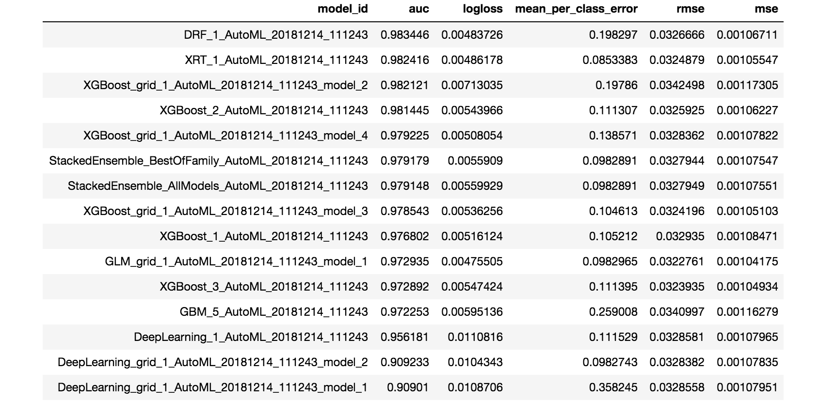

Detailed information for the leader model

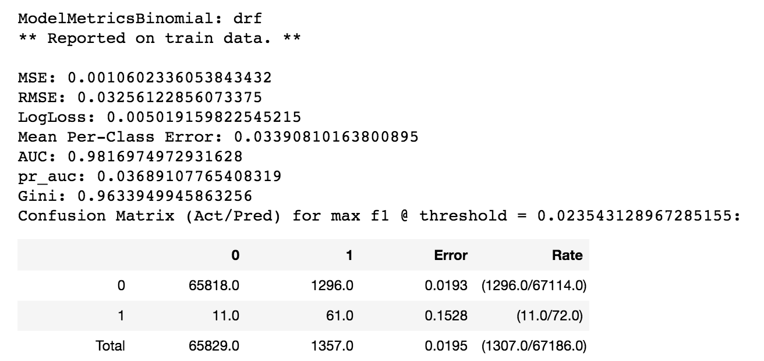

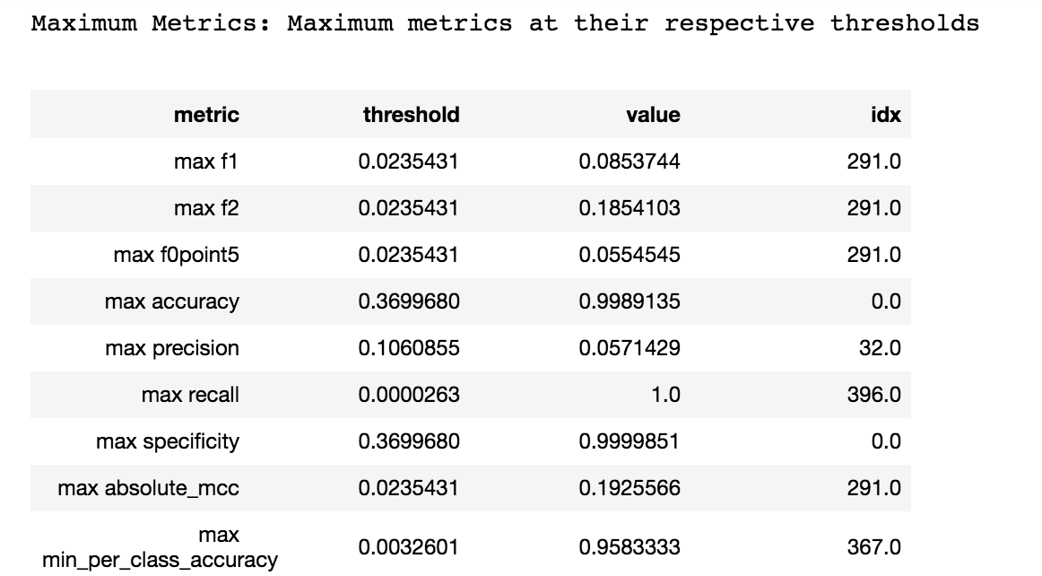

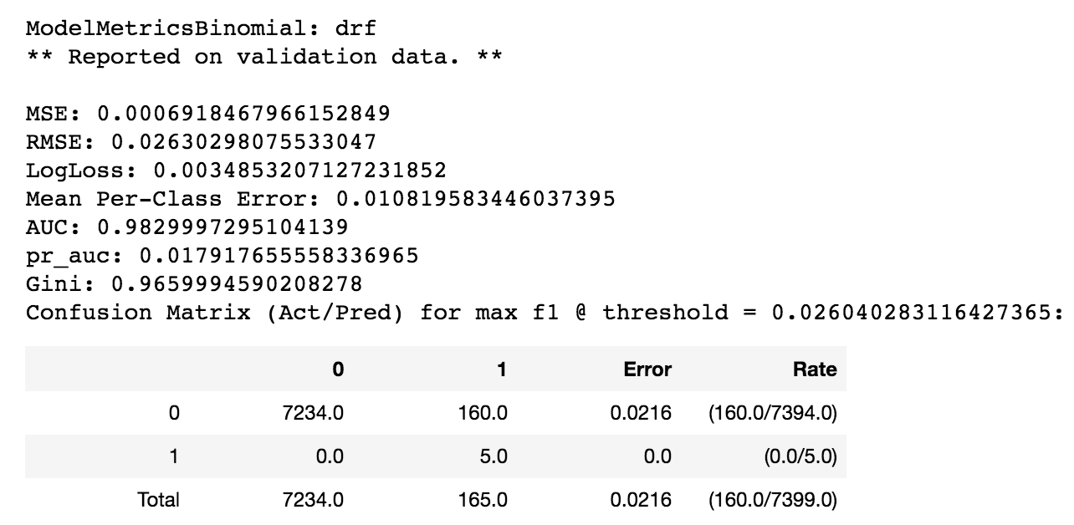

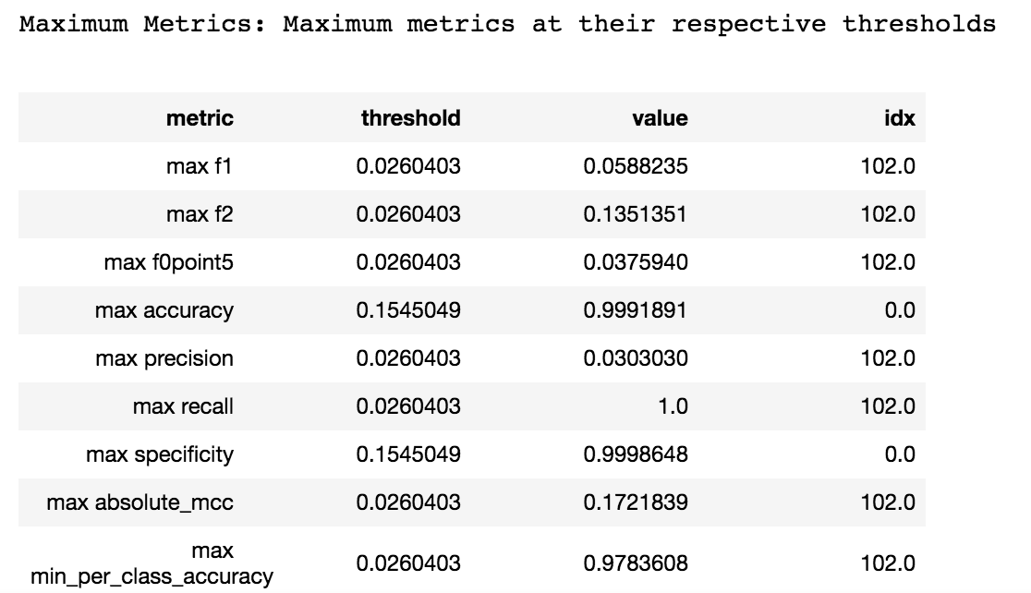

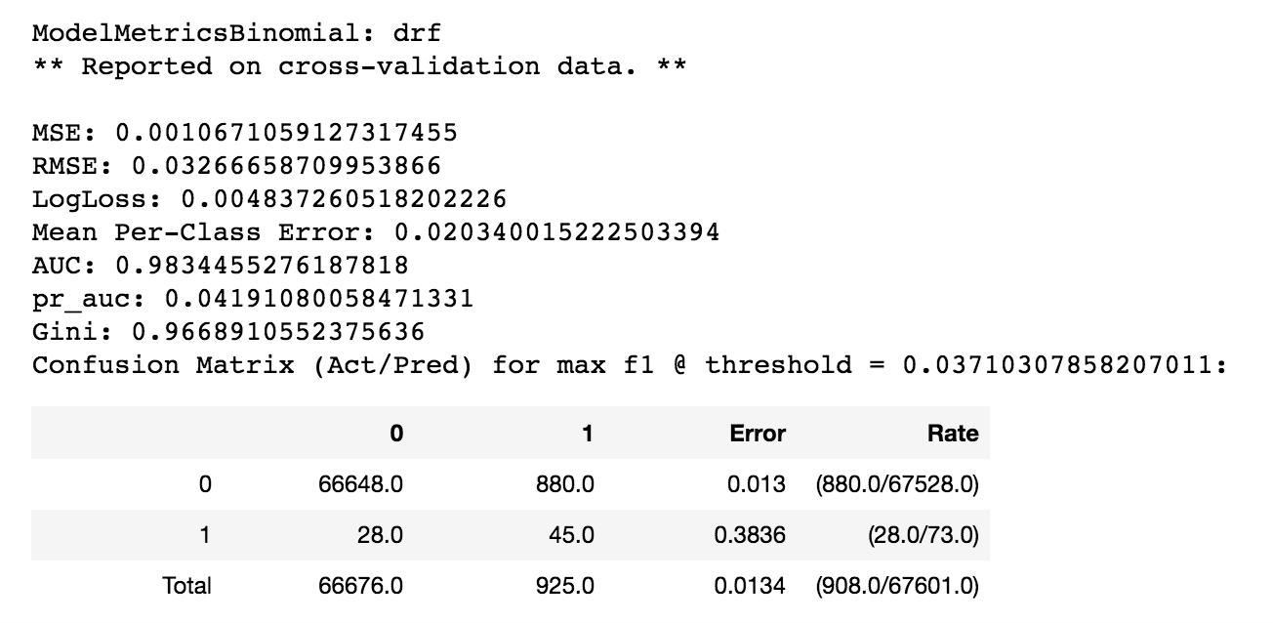

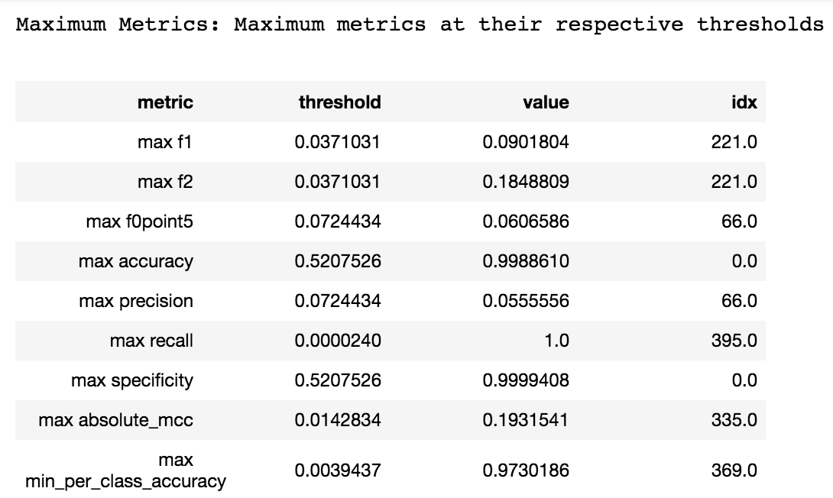

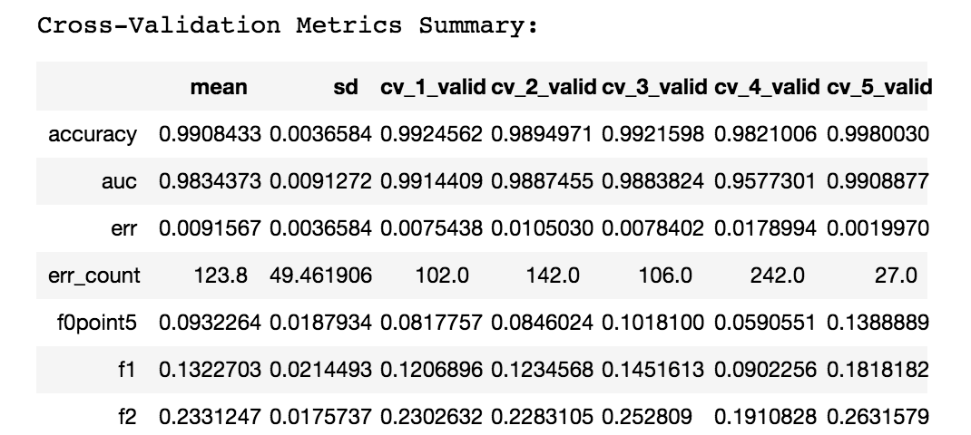

Top 5 important variables:

